NIH Kids Invade St. Mary’s

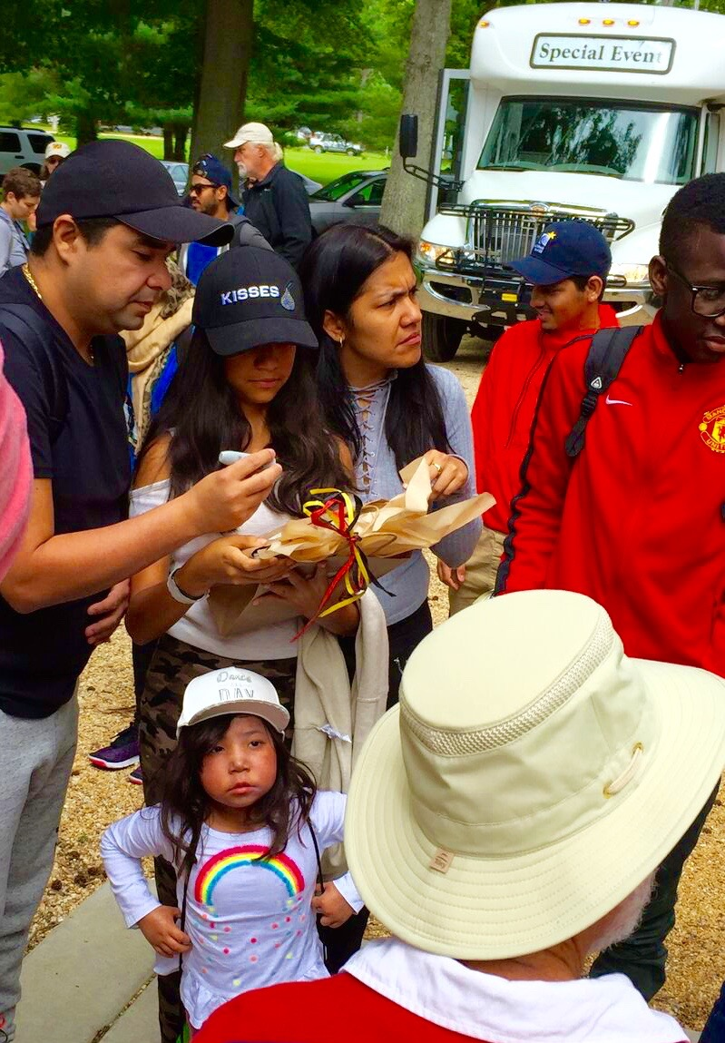
A group of somber kids and family members tumbled off their bus from NIH (National Institutes of Health)
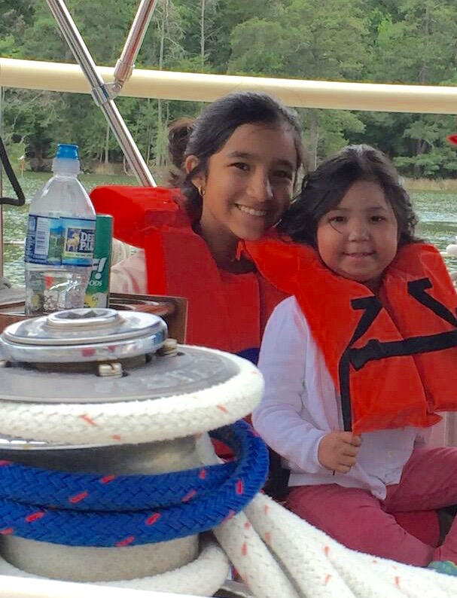

A few hours later, coming in on their boats, they were laughing and wearing grins from ear to ear.

On Wednesday, June 7, some friends, most of whom just happen to look like members of the SMRYC (it was not at all an official club function), played host to a bunch of very sick young people undergoing extended experimental treatments at the NIH facility in Bethesda. The kids came with assorted family members for a day of fun away from the hospital and their living environment there. They were from all over the world including Mauritania, Venezuela, Mongolia, Jamaica, Mexico and the U.S. Bill and Kathie Fry had graciously made their home with its pool available as the base of activity. Other folks helped with lifejackets and making souvenir hats available.

We had six boats organized for the day, three power and three sail. Ted Warren brought his Mary R, the flagship of the fleet; Lani Clark came with Matou for the sailors who wanted to get the feeling of a racer; Bob Smith rolled in with Bella Sera to give new sailors a chance to enjoy an ocean going vessel; Steve and Maureen Bernard brought Stella particularly for folks interested in fishing; Alan Hinkle brought Impulse to give our
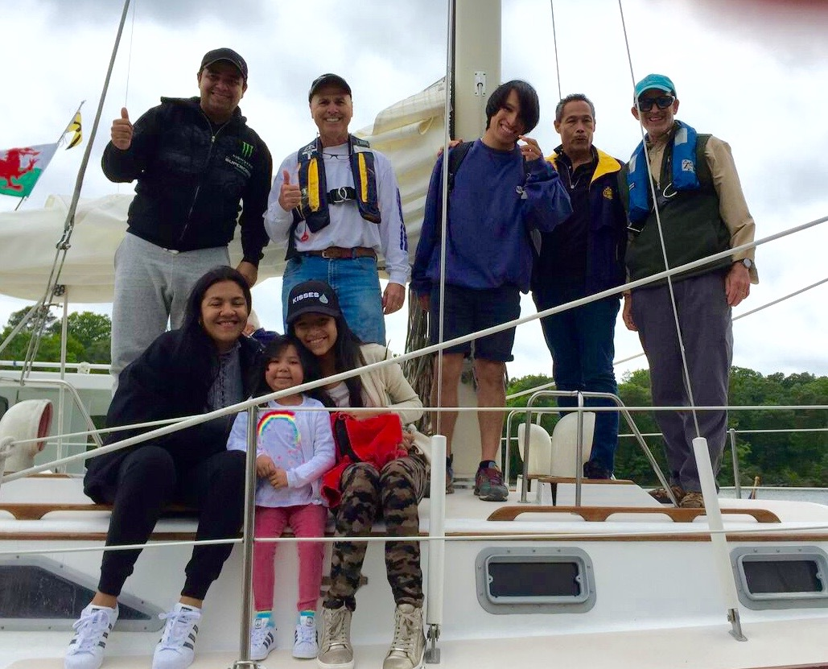
visitors a taste for luxurious cruising; and John Paradis zoomed in with Dark Side to the delight of our speed-oriented folks. Each of the guests got to choose which one they wanted to join. Shortly after their arrival, they headed down the driveway with their respective captains to clamor aboard the boats waiting at the Milburn Creek Marina. Off they went in six different directions. John Fulchiron, Maddy Roberts, Maureen Bernard, Alex Kampf, and Chris Tanner helped with crew responsibilities.
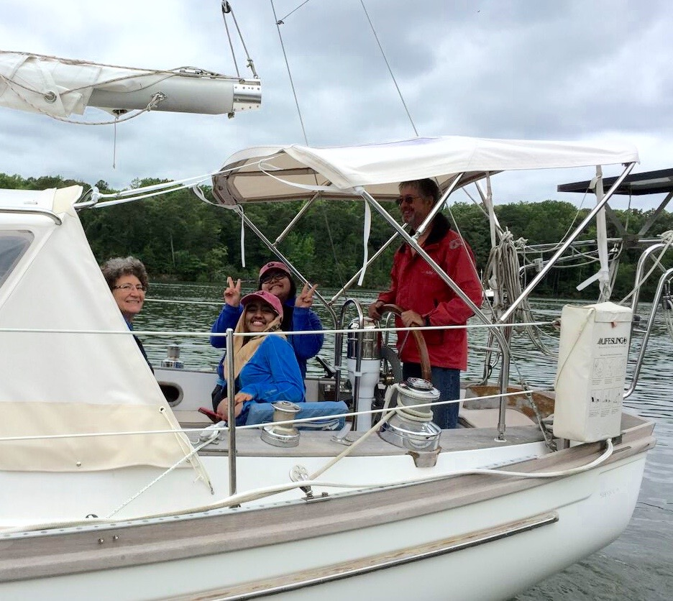

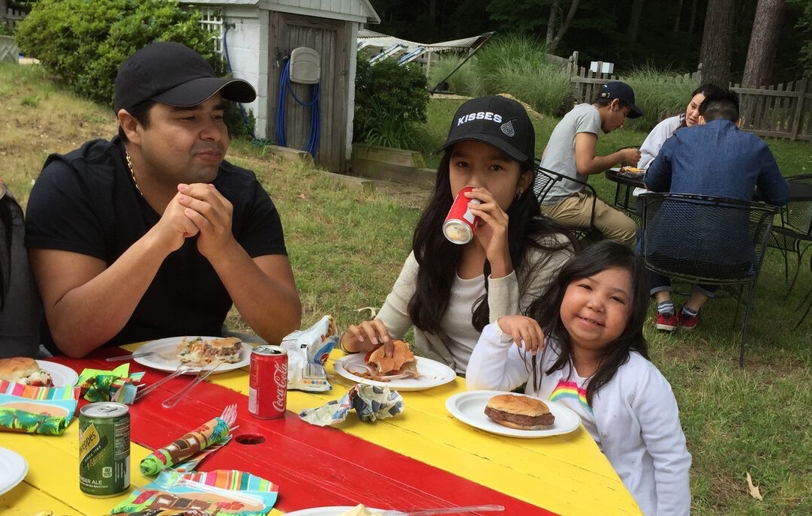
If one did not know how sick they were, it would have been hard to tell the burdens they were carrying when the sailors returned. They were bubbling with enthusiasm and were hungry! Bill had to hustle to keep up with their appetites for hot dogs and hamburgers. Kathie did a yeoman’s job of coordinating everything else. Lots of SMRYC friends pitched into help--Beverly Johnston, Judy Carr, Jean Illingworth, Marcia Greenberg, and Rosemary Hinkle all were involved. The food just kept coming and it just kept disappearing. Despite the brisk temperature, many of the kids couldn’t resist jumping into the pool. They came out shivering, but with big grins as they headed back for more food. We ended the feast with huge platters of watermelon, plates of Cindy Potosky’s cookies, Bozena Pait’s blueberry cake and lots of sticky, gooey s’mores.
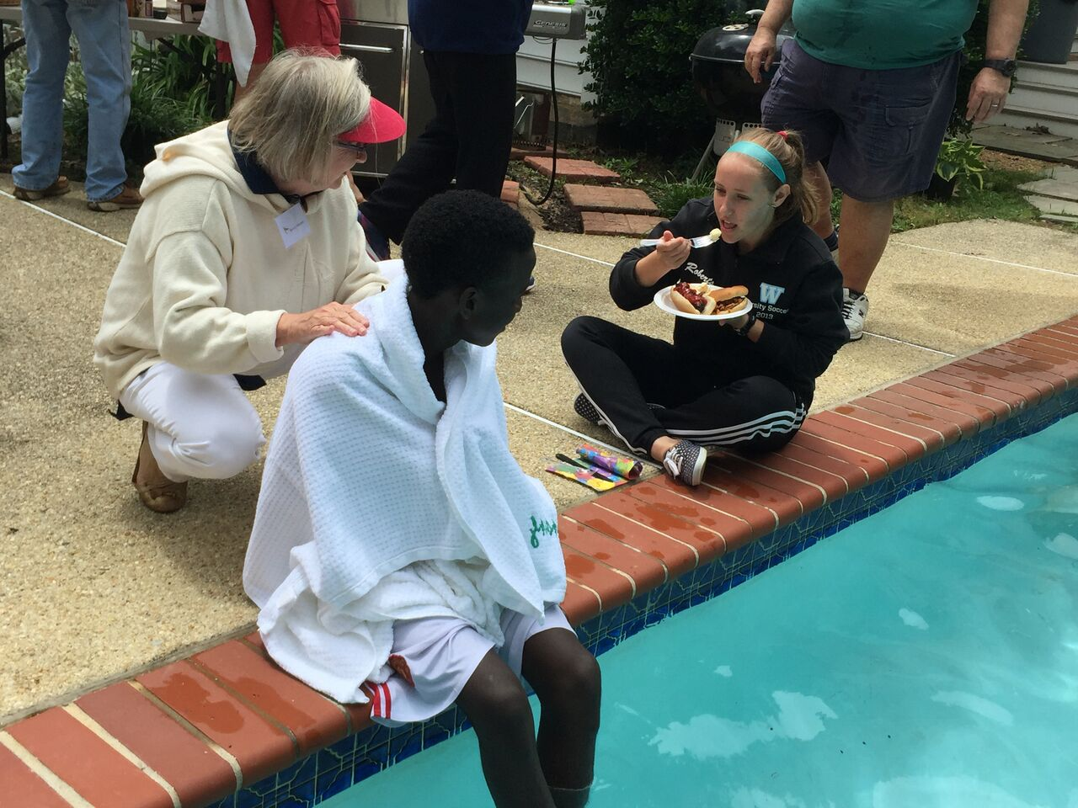

Judging by the number and sincerity of the thanks we received, one could conclude it was a successful day. It was good day not only for the kids in treatment, but also a breath of fresh air for their family members coping with the constant anxiety of medical uncertainty. It was also a good day for everyone involved at the St. Mary’s end. Maybe we should do it again next year.
